# A general catch comparison method for multi-gear trials: application to a quad-rig trawl fishery for *Nephrops*

## Abstract

*Keywords*

## Introduction

*Nephrops Norvegicus* is a commercially important species distributed throughout the North East Atlantic and Mediterranean Sea. Total landings of 66,500 tonnes in 2010 were predominantly attributed to the United Kingdom (58.1%) followed by Ireland (11.7%) and various other European Union (EU) countries operating in Atlantic and Mediterranean waters (FAO, 2010). More than 95% of EU *Nephrops* landings are taken using single or multi-rig trawlers which target *Nephrops* in mixed species fisheries (Ungfors *et al.*, 2013). The use of four trawl multi-rigs (Figure 1) known as quad-rigs commenced in October 2012. By the end of 2014 quad-rigs accounted for ~ 80% of *Nephrops* landings by the Irish fleet with an estimated value at the first point of sale of €44.5M (unpublished data, Marine Institute, Bord Iascaigh Mhara Ireland). This made it the most commercially important demersal species in Ireland in that year.

The main driver for increased uptake of the quad-rig is increased catches of *Nephrops*. Increased catches are likely to result from a wider swept area of seabed without increasing the drag of the gear (Insert seafish ref). *Nephrops* catch weights were observed to increase by at least 50% in the North Sea and Celtic Sea in studies comparing quad with twin-rig trawls (BIM, 2014; Revill *et al.*, 2009). Such increases in catching efficiency may be beneficial in terms of improving operational performance. However, in the context of a discard rate of 15% of total catches of *Nephrops* below minimum landing or market size in Irish waters (MI, 2014), such substantial increases in *Nephrops* catch rates may lead to increases in unwanted Nephrops catches. Discarding of undersized and non-targeted fish species is also a major issue in *Nephrops* trawl fisheries (e.g. Catchpole *et al.*, 2005; Catchpole and Revill, 2008; Nikolic *et al.*, 2015; Ungfors *et al.*, 2013). New requirements to restrict discarding of demersal species under EU regulation 1380/2013, the Landing Obligation (LO), are likely to have negative impacts on the economics of *Nephrops* fisheries unless such catches can be reduced.

Gear modifications to reduce bycatch are generally assessed using either selectivity or catch comparison (TOP CITATIONS). Practical advantages of the catch comparison method include commercial-like performance and handling of the gear. In addition, the ease with which results of catch comparison experiments can be reported and interpreted (Holst and Revill, 2009) is likely to be particularly beneficial in assisting the fishing industry to address challenges posed by the landing obligation. One drawback is that comparisons are only possible with gears included in the experiment (Frandsen, 2010). Utilising a quad-rig trawl increases the number of gears that can be included in the experiment to four, providing more concurrent experimental settings and information than traditional twin or single-rig catch comparisons..

Until recently, modeling approaches for catch comparison data were limited with a general reliance on simple paired tests by length classes. The development of a Generalized Linear Mixed Model (GLMM) approach which provides a statistical and graphical comparison of fish length by different fishing gears with an associated measure of error (Holst and Revill, 2009) greatly improved the power of catch comparison analysis. Based on a logistic model with a binomial error distribution, the approach is, however, limited to two gears. Multinomial models can generalize logistic regression to multiclass problems, i.e. with more than two possible discrete outcomes (McCullagh and Nelder, 1989). They can be used to predict the probabilities of the different possible outcomes of a categorically distributed dependent variable, given a set of independent variables.

Examples of the application of multinomial models to fisheries include analysis of egg stages (Ibaibarriaga *et al.*, 2007; Stratoudakis *et al.*, 2006), comparisons of age-length keys (Gerritsen *et al.*, 2006), fleet behaviour (Ward and Sutinen, 1994) and discard survivability (Benoit *et al.*, 2010). Here, we test the potential benefits of applying a multinomial modelling approach to a comparison of *Nephrops* catches in a quad-rig trawl with four simultaneously deployed test gears.

Here, we extend the method of Holst and Revill (2009) to multi-gear trials. Our goals are dual to 1) develop a multinomial random effects model capable of including: case-specific and choice-specific covariates (link to M&M), cod-end specific sub-sampling, and multivariate random haul effects as found in multi-rig trials (consisting of two or more nets); and 2) apply to data from a designed *Nephrops*  quad-rig trial with four simultaneously deployed diamond mesh cod-end test gears.

## **Materials and Methods**

The model and trial design were developed via a continual collaboration between gear technologists and data analysts. This resulted in both a modified modelling framework and modified trial design to address particular requirements of quad-rig trials. We first describe the trial design followed by the model development.

### Trial design

The Multinomial method is demonstrated here using data collected from a catch comparison experiment carried out in the western Irish Sea, ICES sub-area VIIa, between 18 -21 July 2015. A multi-rig consisting of 4 identical nets (fishing circle 380 x 80mm) each fitted with a codend of nominal mesh size 70, 80, 90 or 100mm. Cod-ends were rotated daily to capture differences in fishing power between the nets (net here describes the whole trawl body). Each cod-end was deployed on each net for 3 hauls which equates to one day. Catches of fish and Nephrops were weighed and random representative subsamples were selected. The carapace length of Nephrops was recorded to the nearest mm below using digital callipers connected to a wireless recording system. Fishing operations approximating normal commercial practice were carried out with haul duration, towing speed and depth of ground fished averaging: 04:47hrs, 3.1 knots and 48m respectively. and the data from 12 consecutive hauls is used in this analysis. Further information on the vessel and gear used in the trial are presented in Table 1 (BIM 2015).



Should we include a table of average catch weight per codend and standard deviation?

### Model development

In a quad-rig trial the response was a matrix of *Nephrops* counts per observation () and cod-end (). Each row contained four counts (one for each cod-end) for length-bin in haul . For example, for the 30mm length bin in haul 5, the response might be denoting that 10 *Nephrops* were counted in the first cod-end, 20 in the second, etc.

The response data are multivariate counts for which interest lies in describing how the relative proportions retained per length-class in each of the cod-ends varies as a function of the cod-end design (predominantly mesh size) and other explanatory variables. When trials consist of counts per category (cod-end), a starting distribution is the multinomial (Agretsi, 2002) with probability mass function

(1)

where: is the count in the th cod-end and ; and is the probability of outcome , , implying 3 parameters in the basic model.

#### Covariates

A common model when explanatory variables are included (such as carapace length) is the multinomial logit model, where the probability of a given outcome depends on values of the explanatory variables for the th observation (row):

, (2)

where is a () row vector of case/row-specific explanatory variables for the th observation and is a () column vector of parameters for the th category. Note that so that the first cod-end is set to the baseline, assuring that the probabilities sum to unity across the categories (Greene, 2000). The explanatory variables, included were: carapace length, net configuration (the cod-end positions were changed each night to account for position effects thus 4 net configurations were tested) and total weight per cod-end. The total weight per cod-end covariate deserves special attention as it requires different treatment to the case-specific variables such as carapace length. Cod-end bulk weights vary by cod-end and can thus be considered a choice-specific attributes. Choice-specific variables in a multinomial setting are typically modelled as conditional logit models (McFadden, 1973), which remove the subscript *k* from the parameter for that covariate, thus for weight the effect is so at equal weights in the cod-end the effect is cancelled. We thus use a mixture of case-specific and choice-specific covariates leading to the fixed effects model

(3)

#### Subsampling offset

As the counts are sub-sampled, it is also necessary to include an offset for the proportion of the catch in each cod-end sampled (Holst and Revill, 2009). In a twin-rig (two category) trial the offset is given by where and are the proportions of the catch sampled in the test and control, respectively (Holst and Revill, 2009). In the quad-rig trial with the proportion of the th net in the th observation sampled, the vector of offsets for the is given by , where the first zero comes from . A numerical illustration of the offset terms is provided in the Appendix. The offset is incorporated as

, (4)

*Multinomial random effects*

Counts for category in a multinomial have an expected mean and variance , however, there is often more variability in the counts than the mean-variance (and covariance) allows for, which is termed overdispersion (Hinde and Demétrio, 1998). This may reflect uncaptured variability or clustering, in particular haul-level variability not accounted for when the observations are treated as independent multinomials. Overdispersion was tested for in the best fitting multinomial model by testing the residual deviance on a chi-squared distribution with the residual degrees of freedom (GET CORRECT CITATION – Paul et al. 1989).

Given that the observations are clustered by hauls, the approach we focus on for accounting for extra-multinomial variability is to include random effects in the model (Hinde and Demétrio, 1998). Multinomial random effects include the baseline category logit random effects model (Hartzel et al., 2001). This model has a multinomial response distribution with the addition of random effects that more explicitly capture the variability attributable to hauls, as opposed to the more general additional variability unattributed to specific grouping but included in, for example, the Dirichlet-multinomial model. The random effects multinomial model we test is an extension of Equation (4) given by

, (7)

where the random effects per haul have a multivariate normal distribution . The baseline category random effect is again set to zero, resulting in a trivariate normal distribution for . An arbitrary (6 parameter) covariance matrix structure, as recommended in Hartzel et al. (2001) was implemented.

#### Inference

We use likelihood ratio tests of nested models to test the significance of each of the fixed effects. As the models are estimated via maximum likelihood we also report Akaike’s Information Criterion for each model. Overall predictions in the presence of a categorical variable (net configuration) were obtained by setting the net configuration values in the predicted model matrix to 1/3 (Fox, 2003).

#### Estimation

Estimation of the multinomial random effects model necessitates integrating over the random effects to estimate the marginal likelihood. We did not find readily available software to fit Equation (7) we therefore wrote an estimation routines in AD Model Builder (ADMB) (Fournier et al., 2012). The ADMB-RE module (Skaug and Fournier, 2006) was used to estimate the multinomial mixed conditional and logit random effects model with the variance-covariance matrix specified via a Cholesky-decomposition. ADMB also allows for estimates of uncertainty on the linear predictor scale via the delta-method approximation. All pre- and post-processing code was run in R 3.2.0 (R Core Team, 2015). Code for running this analysis is stored at (github public repository).

## Results

A total of 15,443 Nephrops were measured during the 12 hauls of the trial. Most of the carapace length measurements were in the range of 20-45mm (Figure 1). Considerable between-haul variability was observed in the proportions retained at length with some hauls displaying consistently lower or higher retention across carapace lengths (Figure 1). The observed proportions at the extremes of the length distribution were more variable but derived from fewer observations (e.g., zero or unity proportions in Figure 1).

Separate inclusion of each of the main effects (carapace length, net configuration and bulk weight) resulted in large decreases in the AIC relative to a model with fixed proportions (Table 1). Net configuration was important with inner port position typically fishing worst, and the outer starboard or port fishing better. These likely reflect non cod-end net differences. Higher-order carapace length effects did not improve the AIC nor residual patterns.Combining carapace length and total cod-end weight or net configuration resulted in a further decreases in the AIC and the model including the three main effects fit best overall (Table 1). A model including carapace length squared was rejected highlighting that over the range of carapace lengths observed a linear model fit best (Table 1). Note that higher-order interactions were not included in the models, as with 12 hauls and 4 mesh types there are 36 independent cells from which to estimate the parameters and the models can quickly become overfit.

From the best fitting model the estimated covariance and correlation matrices of the random effects were:

and , respectively.

Note that the variance of the random effects was similar across the three log-odds ratios (diagonal of ) and strong correlation exists between the random effects (Figure 2). The magnitude of the variance of the random effects (e.g., ) implies that having accounted for the fixed effects of carapace length, net configuration and total cod-end weight (Table 1), the expected proportions vary in extremes by +/- 12% by haul (inverse logit of 95% intervals -0.5, +0.5). Typically the variability will be lower than this (Figure 2). The relatively low inter-haul variability estimated together with the model comparisons (Table 1) highlight that a considerable amount of between-haul variability is captured by the fixed effects of net configuration and bulk weight though some inter-haul variability remains, as captured by the random effects (Figures 2 and 3).

The by-haul predictions fit the data well in both the fixed effects and random effects models (Figure 3) though the random effects models expectedly fit some haul and mesh combinations better (e.g., 70mm and 80mm in hauls 3 and 5). The overall predictions show a higher proportion of small Nephrops retained in the 70mm, this decreases in the 80mm, 90mm and 100mm (Figure 4). In addition the slope of the proportion retained over length classes goes from negative in the 70mm to positive in the 100mm (Figure 4). The estimated confidence intervals on the mean proportions are tight reflecting the number of observations contributing to the mean with the considerable between-haul variability accounted for via the fixed and random effects (Figure 3). Note that confidence intervals on proportions cannot be interpreted separately as the proportions necessarily sum to unity (the region is a simplex).

## Discussion

The uptake of the quad-rig gear in the economically important *Nephrops* fishery was so fast that knowledge of its selectivity did not keep pace. Here, we addresses some of a requirement to develop a statistical framework that incorporates the multivariate response of the gear and how covariates may influence performance. The method is applicable to other catch comparison situations where multiple gears are tested concurrently. The discussion focusses on the variables influencing the proportion of *Nephrops* retained.

Covariate effectscarapace length, net position and total cod-end weight on the catch composition of a diamond mesh cod-end. The proportion of *Nephrops* retained over carapace length varied by mesh size (Figures 3 & 4). Net configuration was an important variable explaining a considerable amount of inter-haul variability (Table 2). Non-rotation of the gears could result in confounding mesh effects with position effects. Position effects may result from differences in fishing power of the nets and asymmetry of: doors, sweeps, net geometry, warp length, washing effects. We found that the simplest way to mitigate for these effects is to rotate the gears so that each gear has multiple opportunities to fish in each position. Logistical constraints limit the number of rotations but we found a rotation each night to be a feasible compromise between logistics and position mitigation. The net configuration was recorded and subsequently included in the model (Table 2).

Total catch weight is known to affect mesh openings and cod-end size selection for a range of fish species (Campos *et al.*, 2003; Herrmann and O’Neill, 2005) and the crustacean Aristeus antennatus (Campos *et al.*, 2003). The significant effect of total catch weight on the proportion of Nephrops caught in the current study confirms the influence of this parameter on an additional crustacean species (*Nephrops norvegicus*). This has important implications for the development of improved selectivity measures in multi-rig trawls. Thought to be associated with lower headline height and altered sweep arrangements, reductions of up to 61% of cod, 38% of haddock, and 59% of whiting were observed in trials which compared catches in quad and twin-rig trawls in the Celtic and North Seas (BIM, 2014; Revill *et al.*, 2009). Substantially lower fish catches associated with quad-rig trawls are likely to result in reduced cod-end mesh opening angles. This may reduce cod-end mesh size selectivity for *Nephrops.* Hence, in addition to the improved catching performance for Nephrops (BIM, 2014; Revill *et al.*, 2009) lower fish catch associated with the quad-rig is likely to be a key factor underlying increased *Nephrops* catches in smaller multi-rig trawls compared with larger multi-rig and single trawls.

Can refer to swedish grid experiment here showing reduced fish catches affected cod-end selectivity and additional measures such as square mesh cod-ends or increased diamond cod-end mesh size to ensure bycatch reduction is optimised.

Incorporation of total catch weight into catch comparison analyses may also contribute to improved sampling power for quad-rig trawls. Wileman *et al.* (1996) describe how sample variance can be reduced by increasing the number of hauls made, the number of fish caught or the rate of sampling of the catches. Assessment of a greater number of test gears in a quad-rig experiment effectively reduces the amount of time available to sample each test gear, potentially leading to increased levels of sample variance. Power analyses may assist in determining optimal numbers of sampled hauls or fish needed to obtain significant results (Herrmann *et al.*, 2015; Wileman *et al.*, 1996). Reducing the duration of hauls may also facilitate increasing the numbers of hauls sampled. However, reduced haul duration is likely to be associated with reduced total catch which we have shown affects Nephrops selectivity. Provided a range of values occur, incorporating total catch quantities into a catch comparison model may facilitate shorter haul durations and improved sampling power in future studies. For a given trial without a range of total catch weights observed, predicting catch composition outside the range amounts to extrapolation, which should be avoided.

The model allows for additional covariates to be included. Variables we did not incorporate in the model include: haul duration, cod-end diameter, wing-end spread, depth, time of day, tidal effects and weather, among others. The effects of these variables will be captured to some extent by the random effects estimated in the model (Figure 3). They could also be included as fixed effects but the number of covariates that can be included is limited by the number of tows and meshes in the trial (i.e., available degrees of freedom).

[DARAGH AND COILIN] Simulation design using these results

Application to other potential fisheries – Daragh.

This method has application in situations where it is necessary to estimate the relative selectivity of multi-rigs consisting of 2 or more gears. In Danish waters multi-rigs consisting of up to 12 nets have been tested. At present the financial outlay for the gear and vessel modifications required to tow more than 4 nets appear to be impediments to their adoption (Seafish, Basic Fishing Methods). In addition, concerns over the increased catching performance and size selectivity of multi-rigs have led to a limit on the number of nets that can be used in a multi-rig, e.g. Ireland (4 nets) and Scotland (2 nets). Other applications: pots, gillnets(?); 12 rigs for shrimp in Denmark, beamers, scallop dredges.

[DARAGH TO EXPAND] Can we make inferences in relation to increased mesh size in relation to Nephrops catches – Is it a good thing?

In Rikke Frandsen’s PhD she puts emphasis on increasing mesh opening angles throughout the length of a codend to steepen the Nephrops size selection curve for a given codend mesh size. She makes the point that diamond codend meshes have a wide range of configurations (mesh opening angles) depending on distance from the catch build up and this contributes to the high variation in the chance of successful contact (escape) of individual Nephrops with a suitably configured mesh. The practical difficulty in legislating for and enforcing measures to govern codend mesh opening angle would suggest that mesh size is the simplest method of reducing undersized Nephrops while acknowledging the potential for losses of marketable Nephrops.

Can we talk about how model could be improved by utilising data on catch volume rather than catch weight. Examples

We don’t collect data on catch volume only catch weight. I don’t think we can extrapolate volume from weight even though we know the catch composition. It may be possible to monitor codend circumference using Scanmar but it is unlikely to be very detailed

Additional paragraphs

[RONAN] For development: Segmentation issue with 80% from quad-rig lumped into TR2.

[DARAGH] Deja-vu from single to twin. Reason for the very fast uptake – don’t have to change much. Cost of change.

[DARAGH] Paragraph on fishing power. In addition to the swept area … Suggest substituting catch rate or catching performance/ efficiency for fishing power.

Defn. of Fishing Power:

The ability of a gear to catch fish of

given species and length class.

Usually a relative measure comparing different gears (to a standard).

Include Hillis paper on whole net

[COILIN AND BRIAN]

Benefits of multinomial to maximizing information in a catch comparison setting compare with selectivity.

Paragrpahs on model context and alternatives.

Future model developments.

Acknowledgements

We are grateful to the owner Ivan Wilde and crew of MFV Our Lass II for their participation during the codend mesh size gear trial. Thanks to Richard Curtin, BIM for estimating the total value of Irish Nephrops landings and to Colm Lordan from the Marine Institute for information on Quad-rig activity in Irish waters. This work was funded by the Irish Government and part financed by the EC under the Irish National Development Plan 2007 – 2013 through the BIM Marine Environment Protection Measure.

**References**

Benoit, H. P., Hurlbut, T., and Chasse, J. 2010. Assessing the factors influencing discard mortality of demersal fishes using a semi-quantitative indicator of survival potential. Fisheries research, 106: 436-447.

BIM. 2014. Catch comparison of Quad and Twin-rig trawls in the Celtic Sea Nephrops fishery, BIM Gear Technology Report. 4 pp.

Campos, A., Fonseca, P., and Erzini, K. 2003. Size selectivity of diamond and square mesh cod ends for four by-catch species in the crustacean fishery off the Portuguese south coast. Fisheries research, 60: 79-97.

Catchpole, T., Frid, C., and Gray, T. 2005. Discards in North Sea fisheries: causes, consequences and solutions. Marine Policy, 29: 421-430.

Catchpole, T., and Revill, A. 2008. Gear technology in Nephrops trawl fisheries. Reviews in Fish Biology and Fisheries, 18: 17-31.

FAO 2010. Landing data for Nephrops norvegicus in 1955–2010 using FAO programme and database FishStatJ. <http://www.fao.org/fishery/statistics/software/fishstatj/en>.

Frandsen, R. P., 2010. Reduction of discards in the Danish Nephrops (*Nephrops norvegicus*) directed trawl fisheries in Kattegat and Skagerrak. Aalborg University, The Faculty of Engineering and Science, Department of Biotechnology, Chemistry and Environmental Engineering. Ph.D., 135 pp.

Gerritsen, H. D., McGrath, D., and Lordan, C. 2006. A simple method for comparing age–length keys reveals significant regional differences within a single stock of haddock (Melanogrammus aeglefinus). ICES Journal of Marine Science: Journal du Conseil, 63: 1096-1100.

Herrmann, B., and O’Neill, F. G. 2005. Theoretical study of the between-haul variation of haddock selectivity in a diamond mesh cod-end. Fisheries research, 74: 243-252.

Herrmann, B., Sistiaga, M., Santos, J., and Sala, A., 2015. How many fish need to be measured in trawl selectivity studies? ICES-FAO Working Group on Fishing Technology and Fish Behavior. IPMA, Lisbon, pp.

Holst, R., and Revill, A. 2009. A simple statistical method for catch comparison studies. Fisheries research, 95: 254-259.

Ibaibarriaga, L., Bernal, M., Motos, L., Uriarte, A., Borchers, D. L., Lonergan, M. E., and Wood, S. N. 2007. Characterization of stage-classified biological processes using multinomial models: a case study of anchovy (Engraulis encrasicolus) eggs in the Bay of Biscay. Canadian Journal of Fisheries and Aquatic Sciences, 64: 539-553.

McCullagh, P., and Nelder, J. A. 1989. Generalized Linear Models. 2nd edition*,* Chapman and Hall, London, UK. 512 pp.

MI. 2014. The Stock Book 2014 : Annual Review of Fish Stocks in 2014 with Management Advice for 2015. Galway, Ireland, 624 pp.

Nikolic, N., Diméet, J., Fifas, S., Salaün, M., Ravard, D., Fauconnet, L., and Rochet, M.-J. 2015. Efficacy of selective devices in reducing discards in the *Nephrops* trawl fishery in the Bay of Biscay. ICES Journal of Marine Science.

Revill, A., Course, G., and Pasco, G., 2009. More prawns and fewer cod caught in trials with multi-rig prawn trawl, CEFAS. 3 pp.

Stratoudakis, Y., Bernal, M., Ganias, K., and Uriarte, A. 2006. The daily egg production method: recent advances, current applications and future challenges. Fish and Fisheries, 7: 35-57.

Ungfors, A., Bell, E., Johnson, M. L., Cowing, D., Dobson, N. C., Bublitz, R., and Sandell, J. 2013. Chapter Seven - Nephrops Fisheries in European Waters. *In* Advances in Marine Biology, pp. 247-314. Ed. by L. J. Magnus, and P. J. Mark. Academic Press.

Ward, J. M., and Sutinen, J. G. 1994. VESSEL ENTRY-EXIT BEHAVIOR IN THE GULF-OF-MEXICO SHRIMP FISHERY. American Journal of Agricultural Economics, 76: 916-923.

Wileman, D. A., Ferro, R. S. T., Fonteyne, R., and Millar, R. B., 1996. Manual of methods of measuring the selectivity of towed fishing gears. ICES cooperative research report. 215, 126 pp.

## Modelling references – to be included above (Brian, please!)

Agresti, A. (2002). *Categorical Data Analysis* (2nd edition). John Wiley & Sons, Inc., Hoboken, New Jersey.

Chen, J., & Li, H. (2013). Variable selection for sparse dirichlet-multinomial regression with an application to microbiome data analysis. *The Annals of Applied Statistics*, 7(1) 1-25.

Fournier, D.A., H.J. Skaug, J. Ancheta, J. Ianelli, A. Magnusson, M.N. Maunder, A. Nielsen, and J. Sibert. (2012). AD Model Builder: using automatic differentiation for statistical inference of highly parameterized complex nonlinear models. *Optimization Methods Software*. 27:233-249.

Fox, J. (2003). Effect Displays in R for Generalised Linear Models. Journal of Statistical Software, 8(15), 1-27.

Greene, W.H. (2000). *Econometric Analysis* (4th edition). Prentice Hall, Upper Saddle River, New Jersey.

Hartzel, J., Agresti A., and Caffo, B. (2001). Multinomial logit random effects models. *Statistical Modelling*, 1, 81-102.

Hinde, J. and Demétrio, C.G.B (1998). Overdispersion: models and estimation. *Computational Statistics & Data Analysis* 27(2) : 151-170.

Holst, R. and Revill, A. (2009). A simple statistical method for catch comparison studies. *Fisheries Research* 95(2): 254-259.

McFadden, D. (1973). Conditional logit analysis of qualitative choice behavior. In P. Zarembka, ed., *Frontiers in Econometrics*. New York: Academic Press.

Miller, T.J. (2013). A comparison of hierarchical models for relative catch efficiency based on paired-gear data for US Northwest Atlantic fish stocks. *Canadian Journal of Fisheries and Aquatic Sciences*, 70: 1306-1316.

Paul, S.R., Liang, K.Y. and Self, S.G. (1989). On testing departure from the binomial and multinomial assumptions. *Biometrics*, 45: 231-236.

Plummer, M. (2003). JAGS: A Program for Analysis of Bayesian Graphical Models Using Gibbs Sampling. Proceedings of the 3rd International Workshop on Distributed Statistical Computing (DSC 2003), March 20–22, Vienna, Austria. ISSN 1609-395X.

R Core Team (2015). R: A language and environment for statistical computing. R Foundation for Statistical Computing, Vienna, Austria. URL <http://www.R-project.org/>

Skaug, H.J. and Fournier, D.A. (2006). Automatic approximation of the marginal likelihood in non-Gaussian hierarchical models. Computational Statistics & Data Analysis, 51(2): 699–709.

Table 1, vessel and gear information

|  |  |
| --- | --- |
| Vessel | Our Lass II (DA261) |
| Vessel Length Overall | 21.7m |
| Engine power | 484kW |
| Home port | Howth, Ireland |
| Trawl type | Quad-rig Nephrops |
| Trawl manufacturer | Pepe Trawls Ltd., Ireland |
| Otter board manufacturer/ type | Dunbar 7’6” |
| Door weight | 492kg |
| Clump weight type/ weight | Roller/ 680kg |
| Door to clump spread (average) | 34.4m |
| Sweep length | 50 + 20m |
| Codend nominal mesh size | Codend measured mesh size |
| 70mm | 70.8mm |
| 80mm | 80.8mm |
| 90mm | 92.6mm |
| 100mm | 103.0mm |

Table 1. Multi-rig catch comparison. Multinomial random effects model fit summary. Explanatory variables are abbreviated: carapace length (CL), net configuration (NC) and cod-end total weight (W). The model degrees of freedom (df) includes 6 parameters parameterising the trivariate covariance matrix of the random effects.

|  |  |  |  |
| --- | --- | --- | --- |
| Explanatory variables | Log-likelihood | Model df | AIC |
| None | -2084.79 | 9 | 4187.58 |
| CL | -2062.56 | 12 | 4149.12 |
| NC | -2049.41 | 18 | 4134.82 |
| W | -2058.52 | 10 | 4137.04 |
| CL + NC | -2027.31 | 21 | 4096.62 |
| CL + W | -2036.2 | 13 | 4098.4 |
| NC + W | -2039.81 | 19 | 4117.62 |
| CL + NC + W | -2017.17 | 22 | 4078.34 |
| CL + CL2 + NC + W | -2016.79 | 25 | 4083.58 |

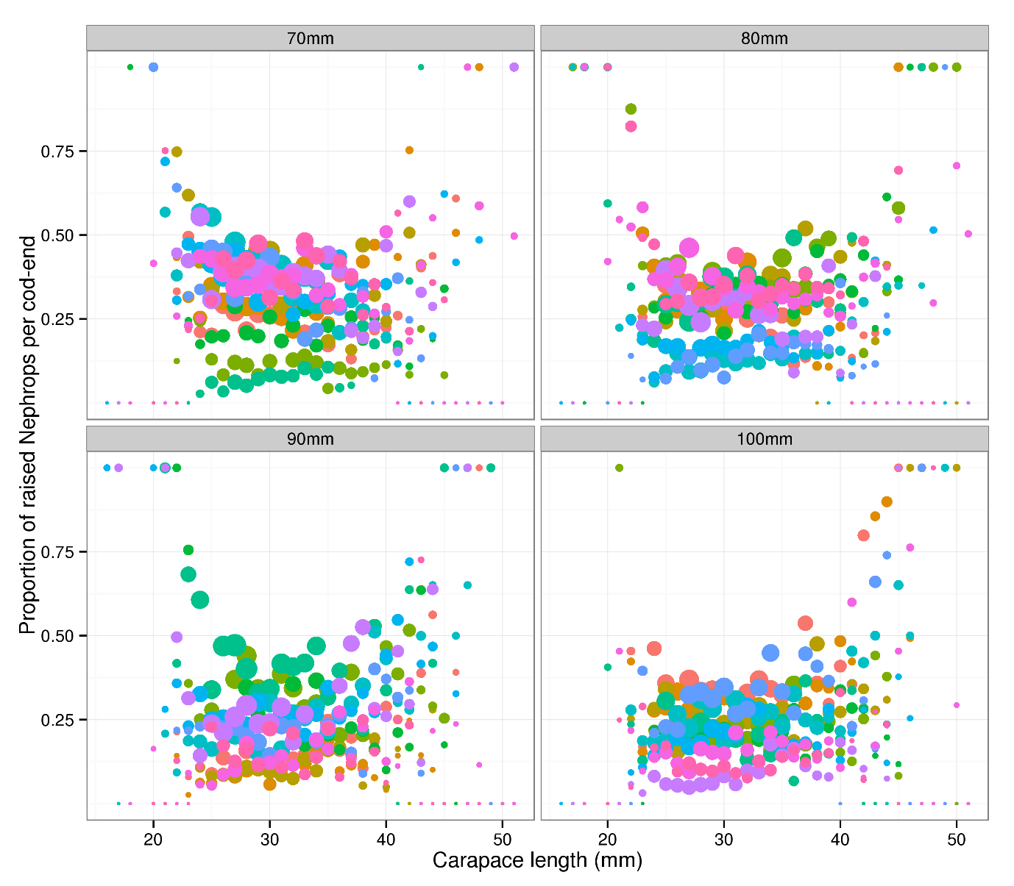

Figure 1. Multi-rig catch-comparison. Proportion of Nephrops retained per length-class by diamond mesh size. Hauls are coloured to demonstrate the haul effects. The diameter of the points is proportional to the log base 10 of the raised counts to illustrate where the distribution of the counts.

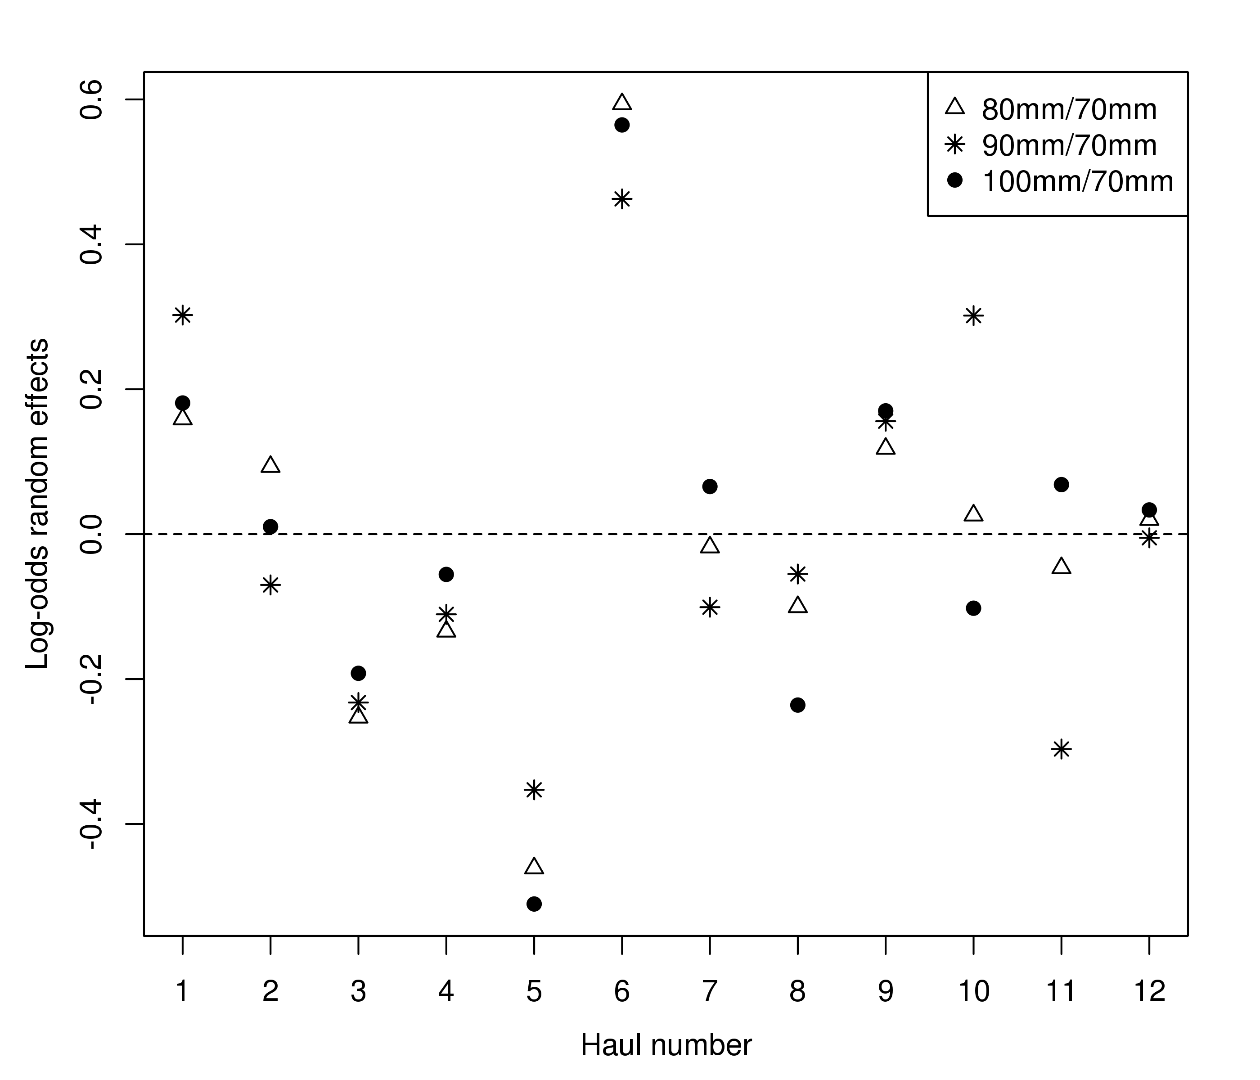

Figure 2. Multi-rig catch comparison. Estimated trivariate random effects (log-odds ratios to the baseline 70mm case: in Equation 6) by haul.

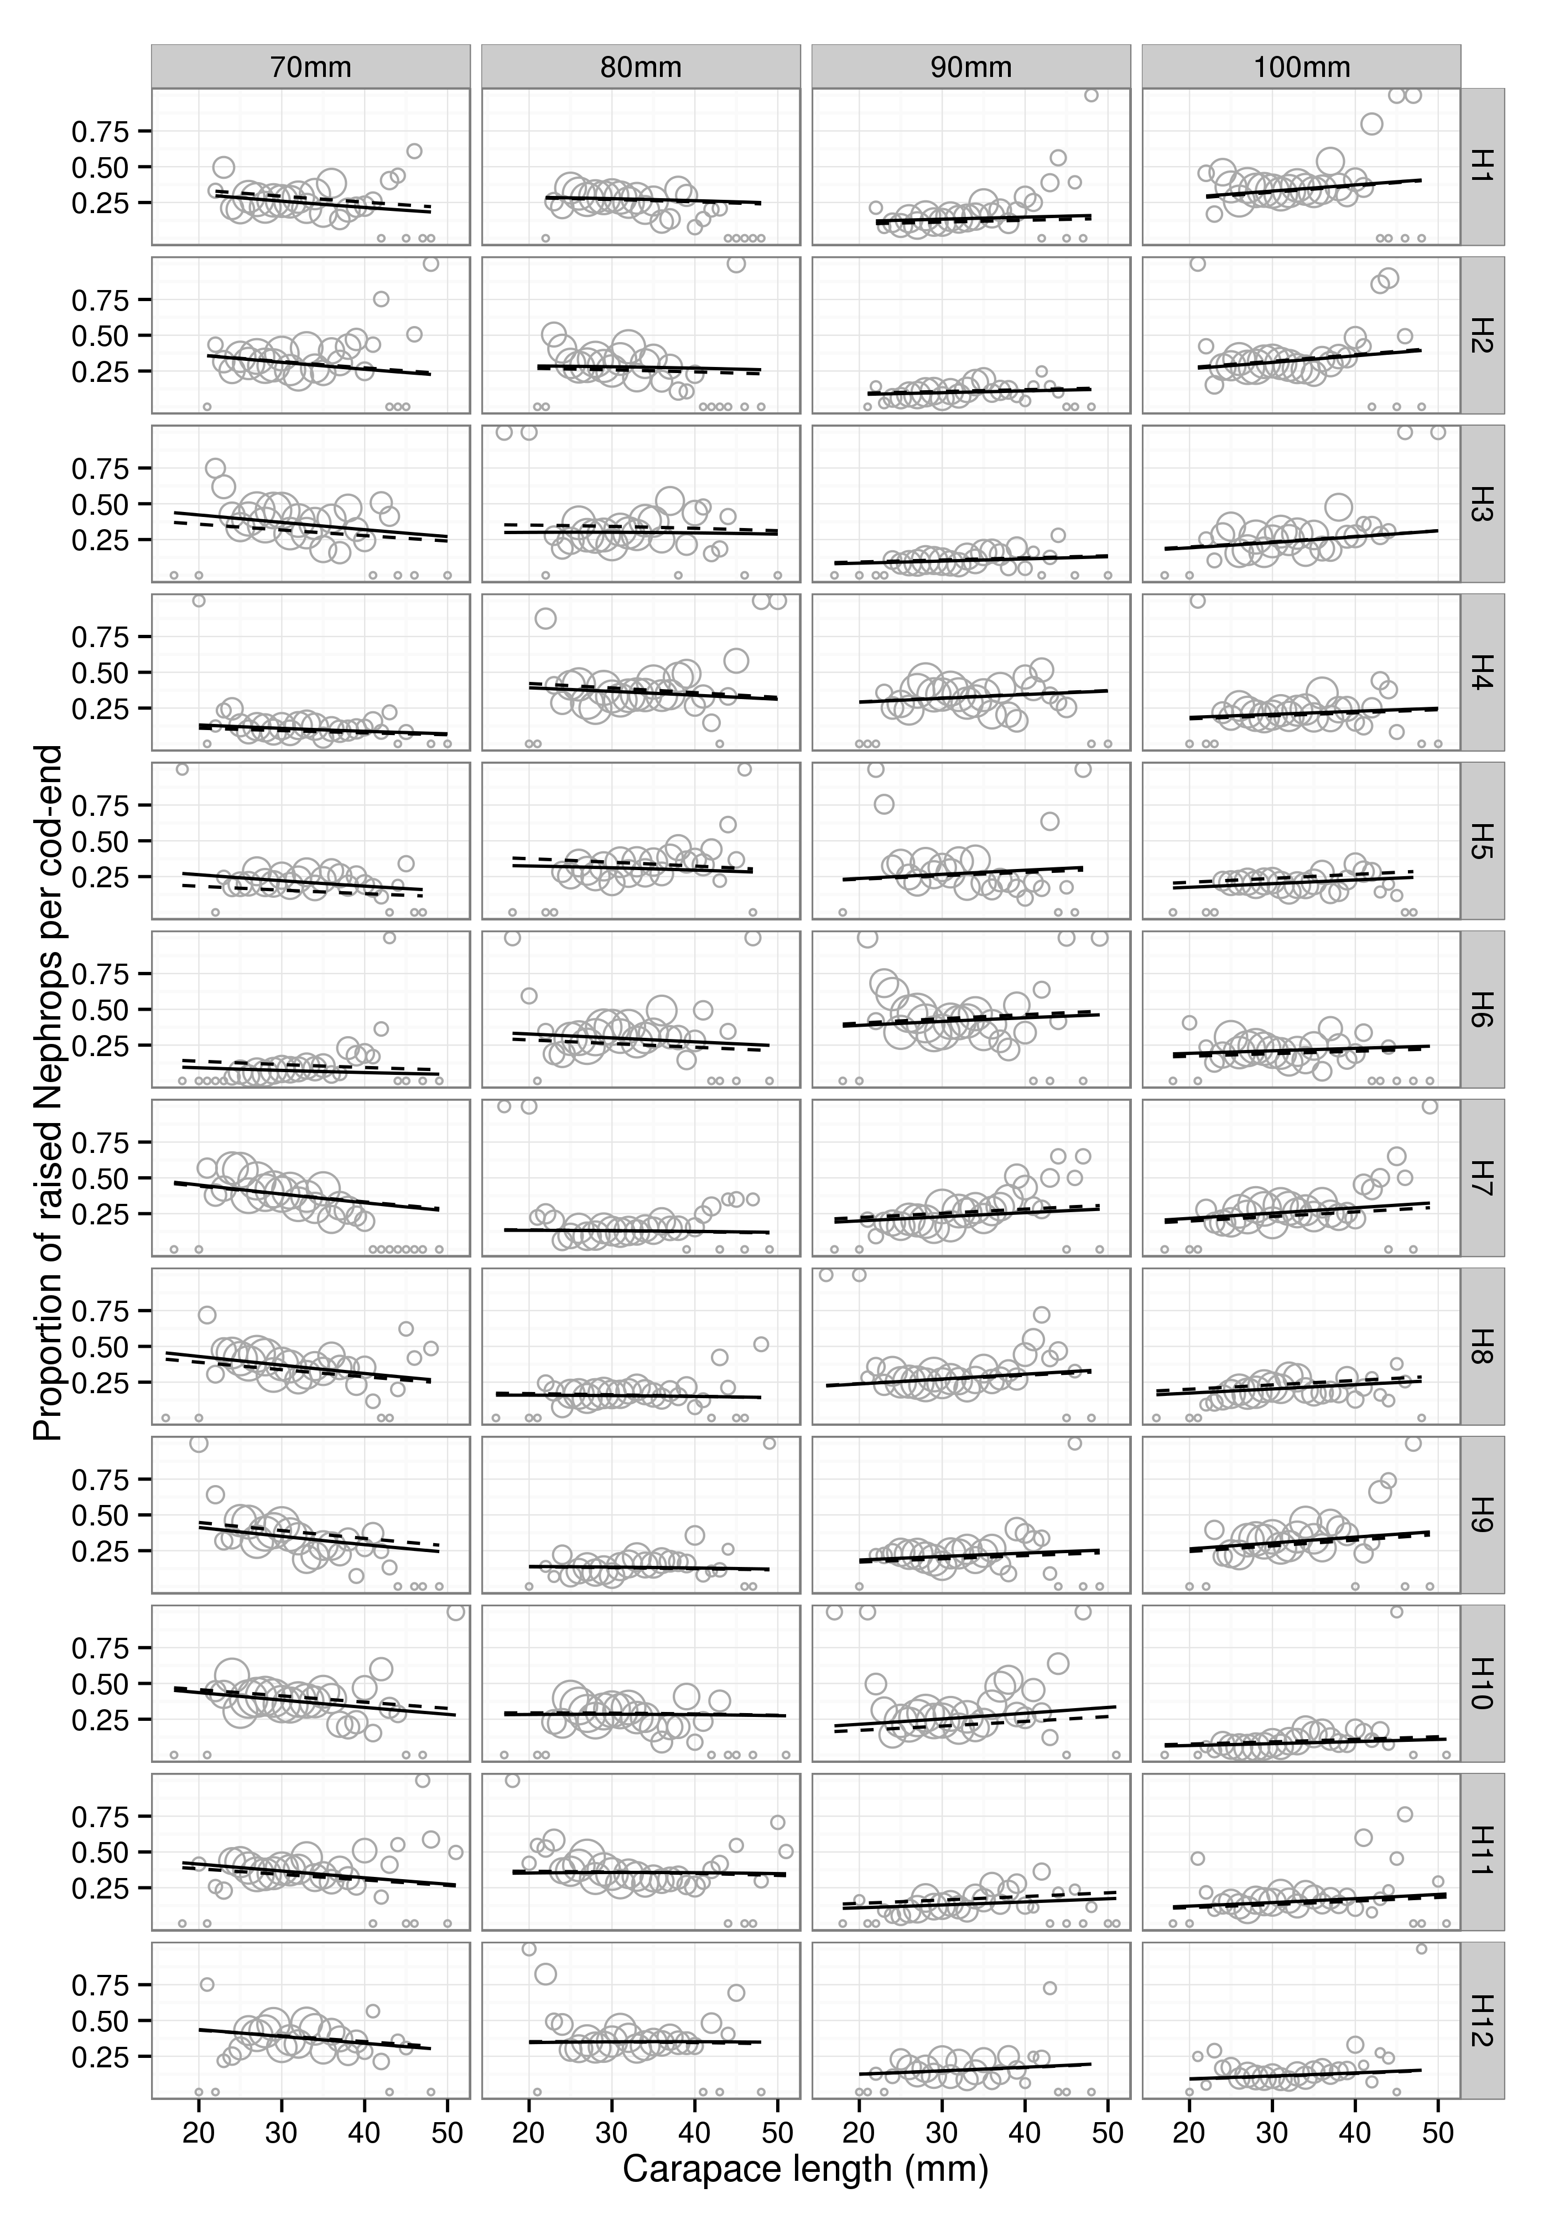

Figure 3. Multi-rig catch comparison. Fitted multinomial mixed effects proportions by haul. Solid and dashed lines represent the predictions from the best fitting model with and without random effects

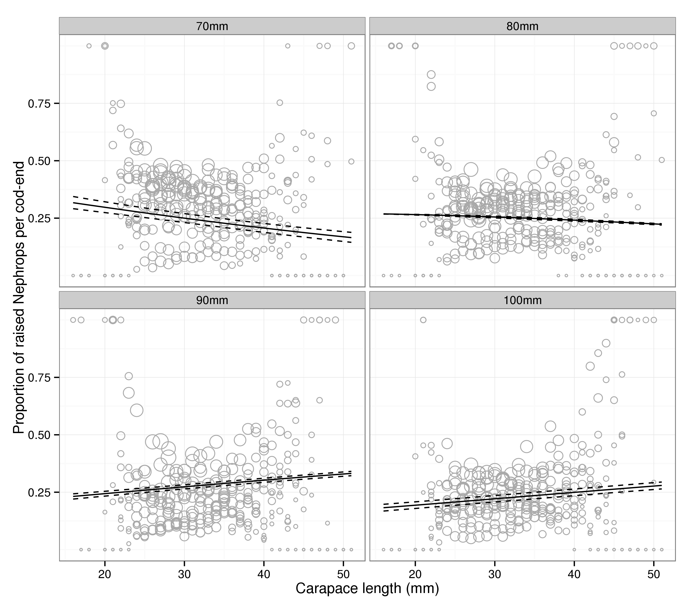

Figure 4. Multi-rig catch comparison. Overall predicted proportions at length. Solid and dashed lines represent the mean and 95% confidence intervals on the mean (see text for discussion on confidence intervals in this setting).